STOCK MARKET CHARTING

MILESTONE 1

GitHub: https://github.com/Madhupreethajkp/Milestone1

Employee Id: 765623

Name: Madhupreetha.J

INDEX PAGE



ADMIN LOGIN PAGE

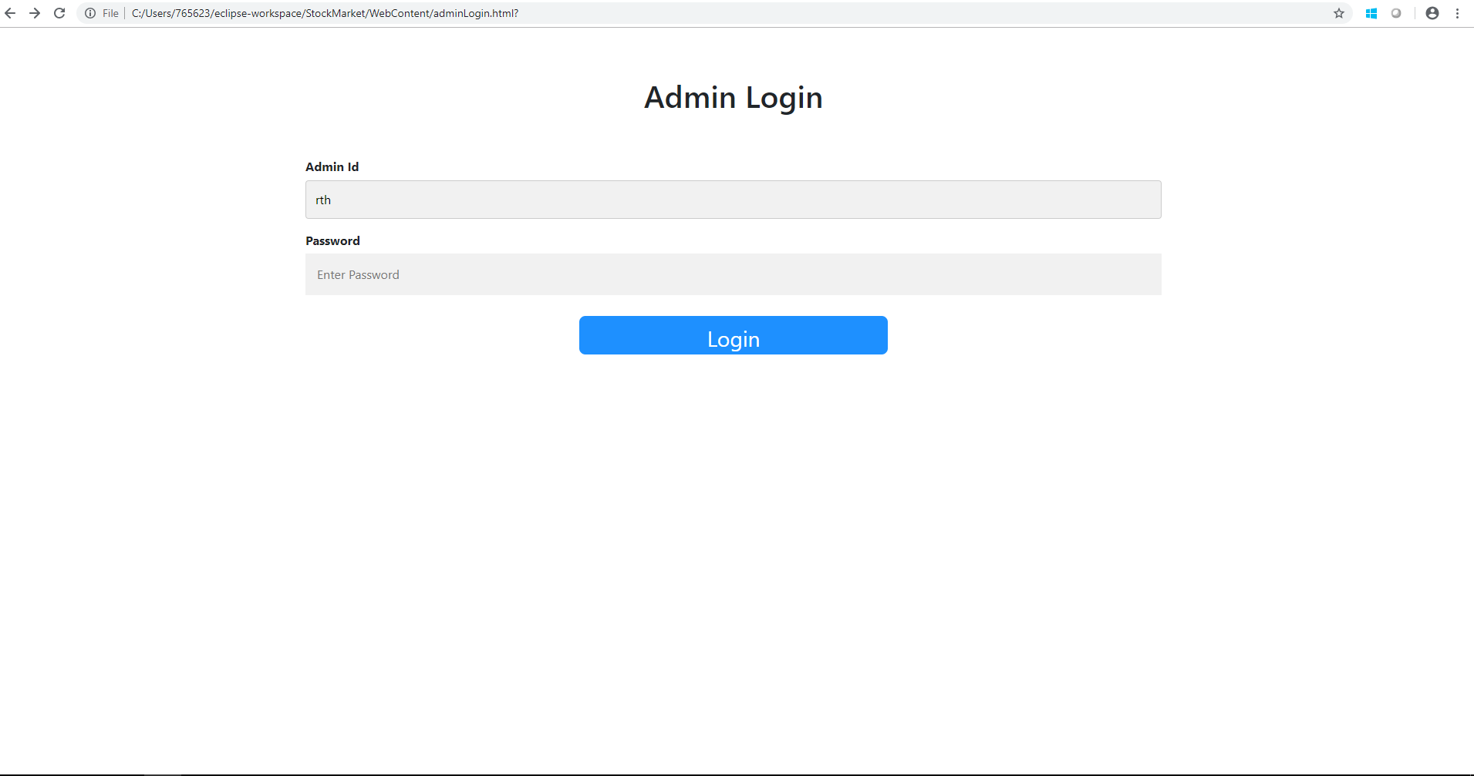

ADMIN LANDING PAGE

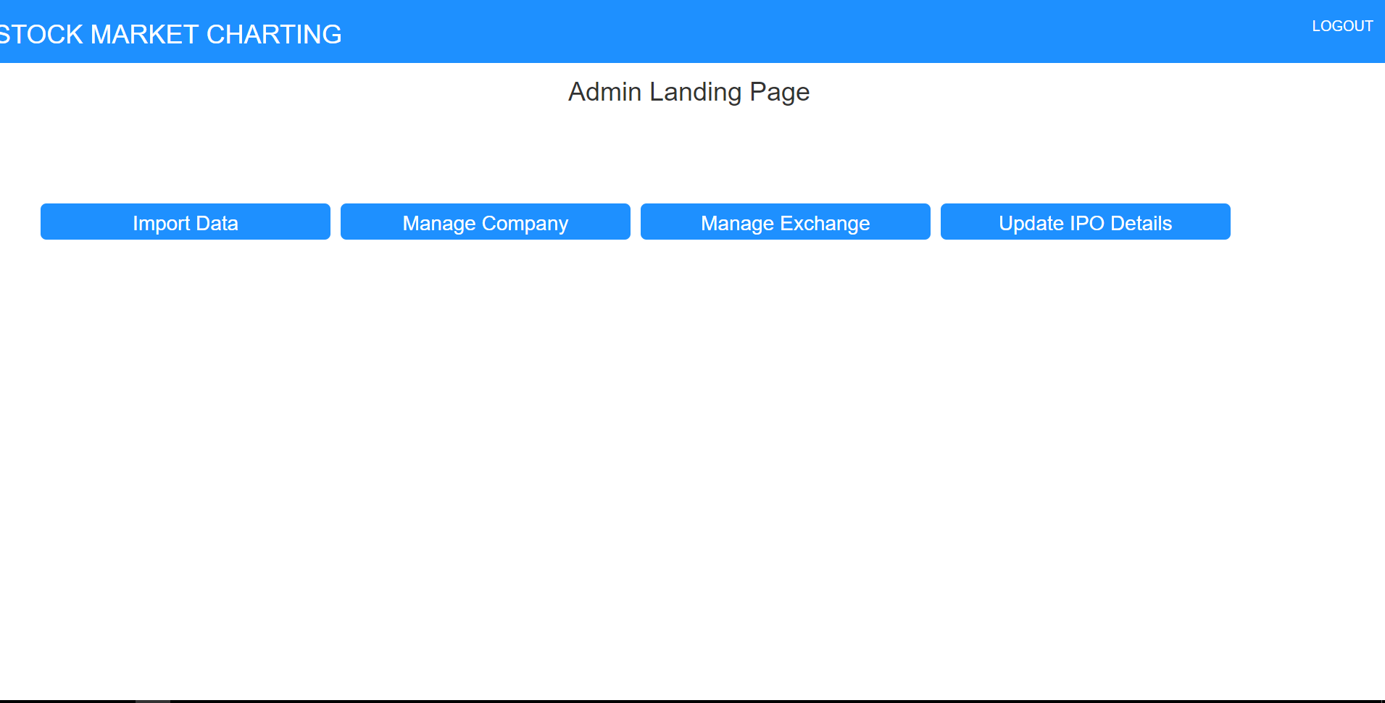

IMPORT DATA

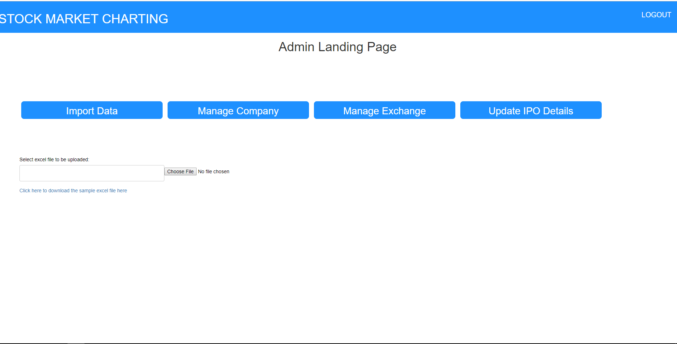

SAMPLE UPLOADED FILE

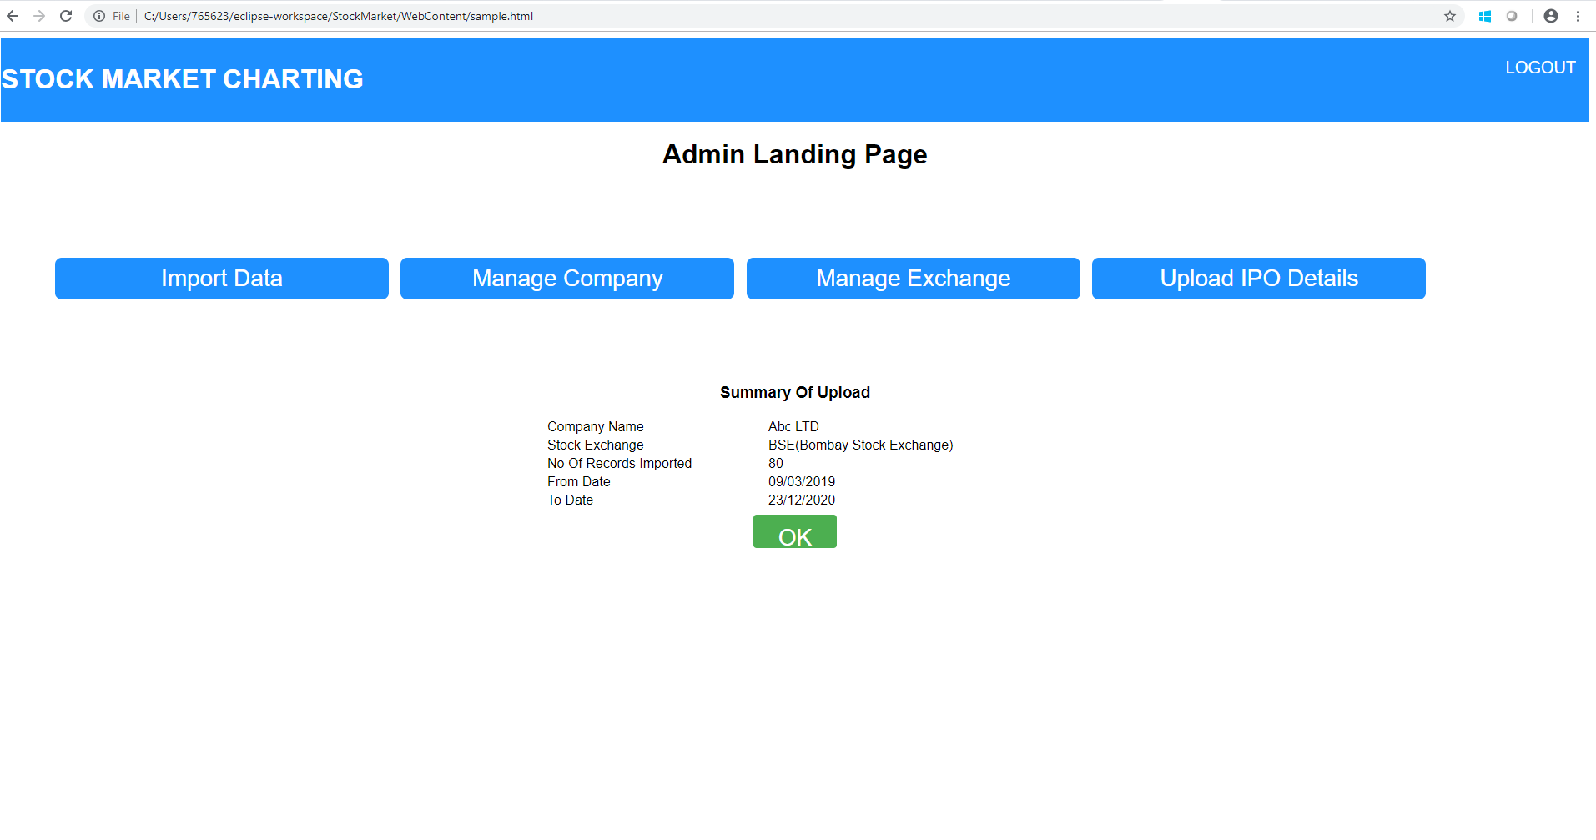

MANAGE COMPANY

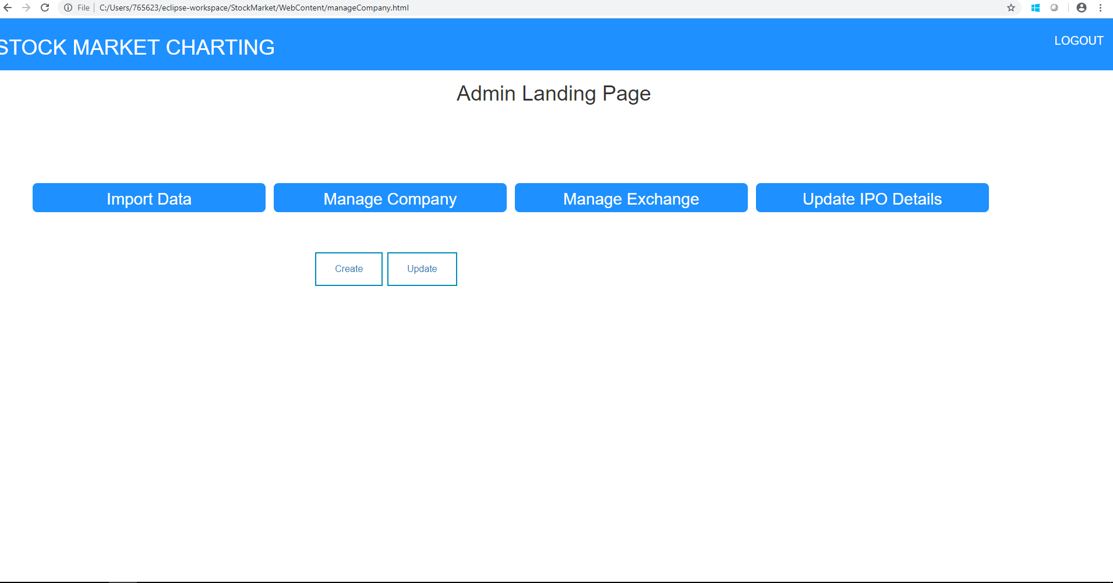

COMPANY FORM

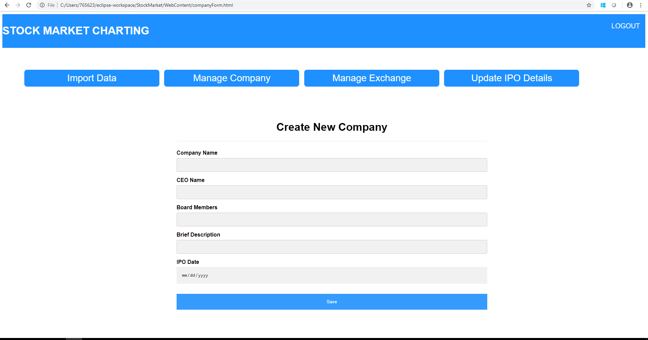

EDIT COMPANY

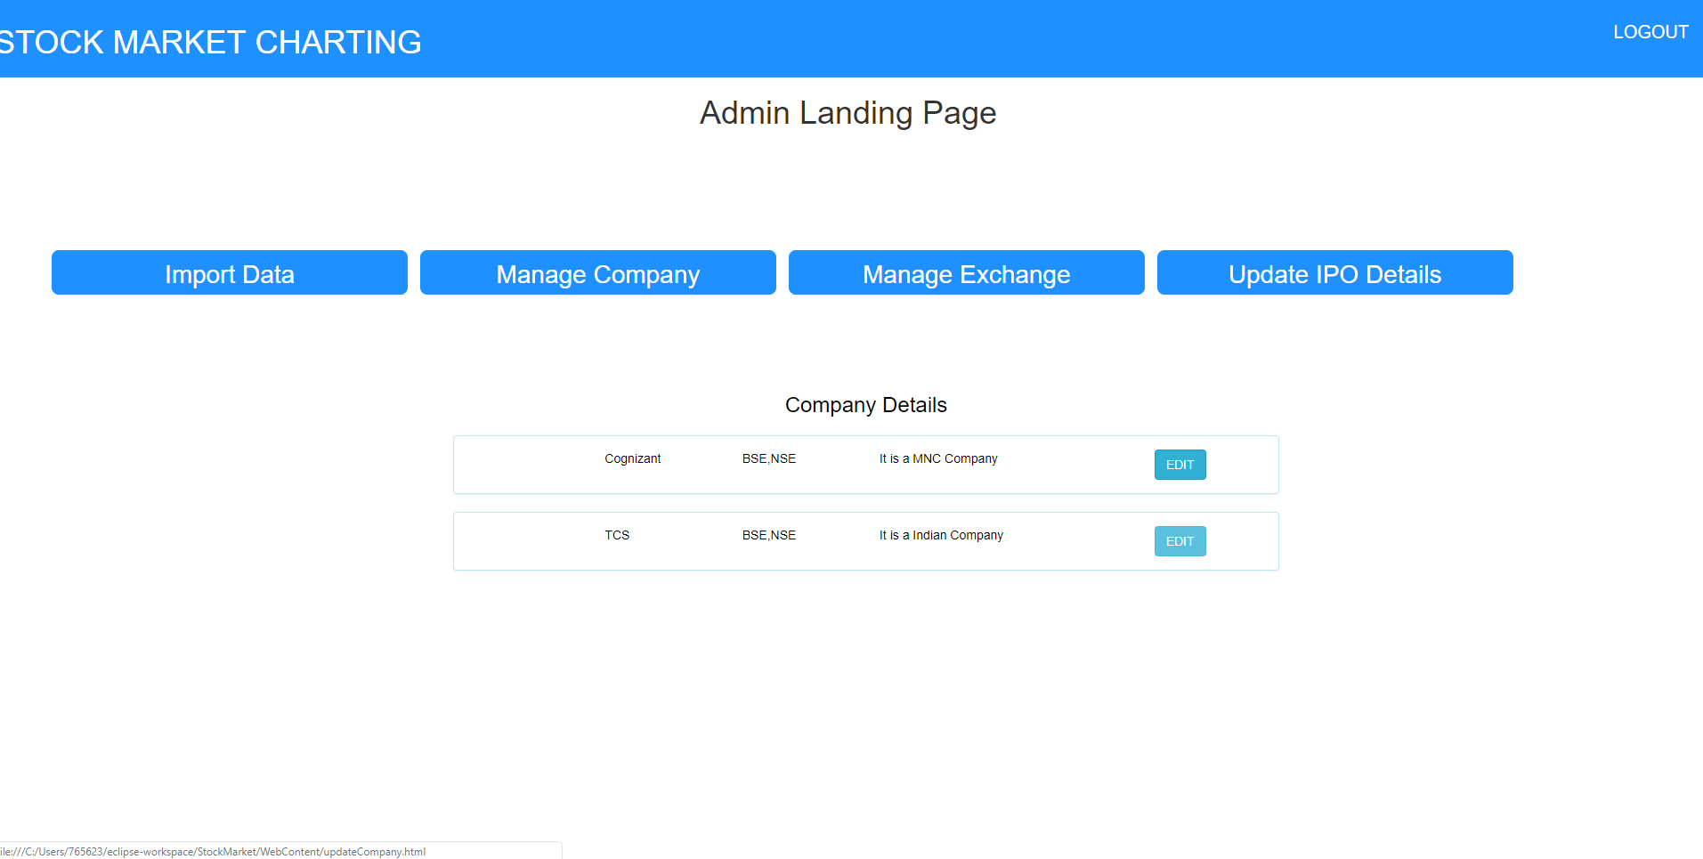

EDIT COMPANY FORM

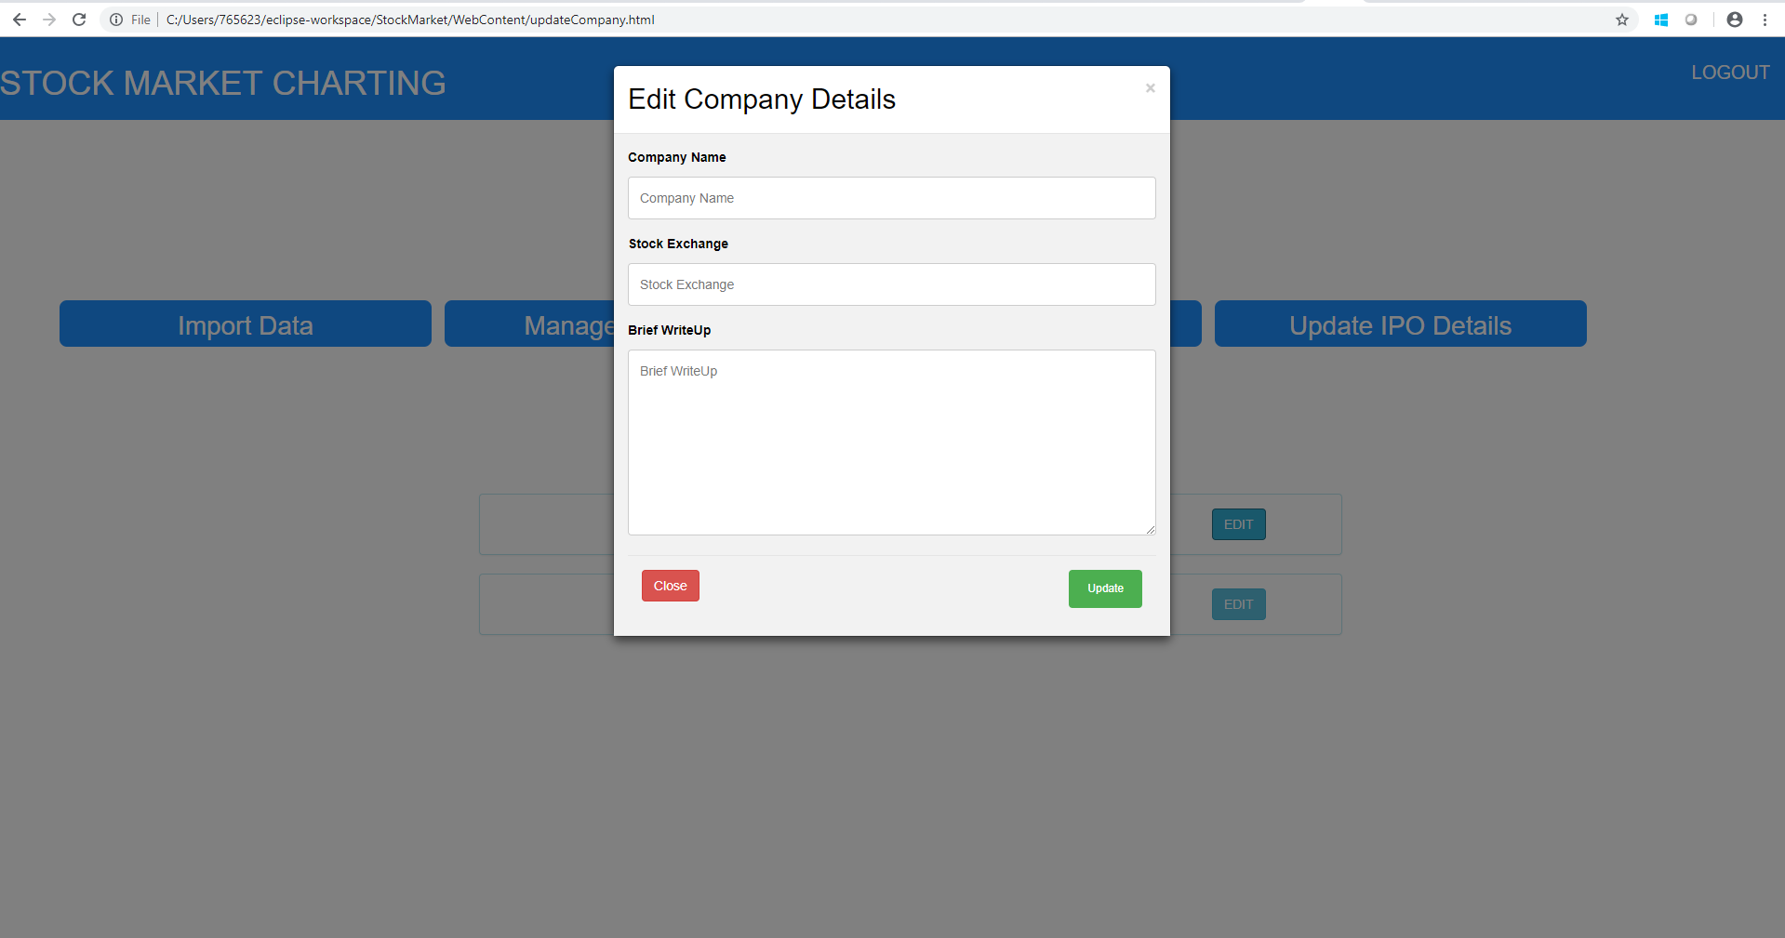

MANAGE EXCHANGE

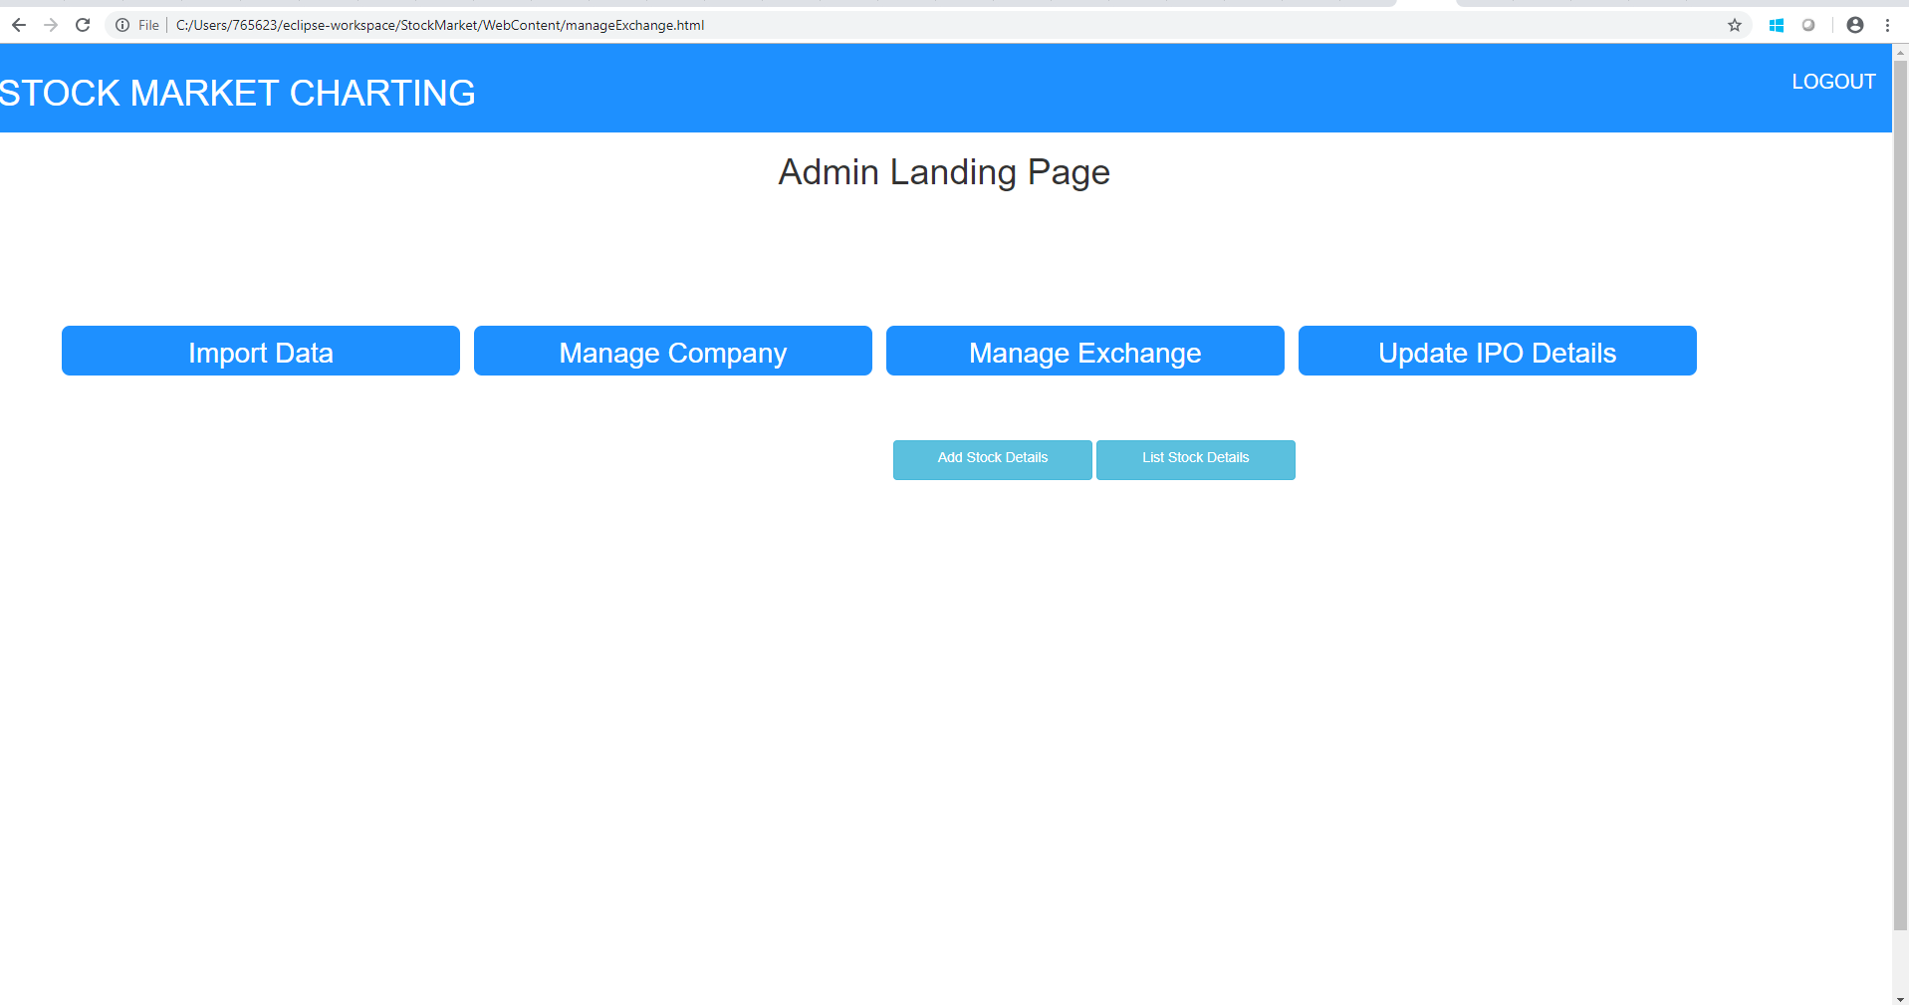

ADD STOCK DETAILS

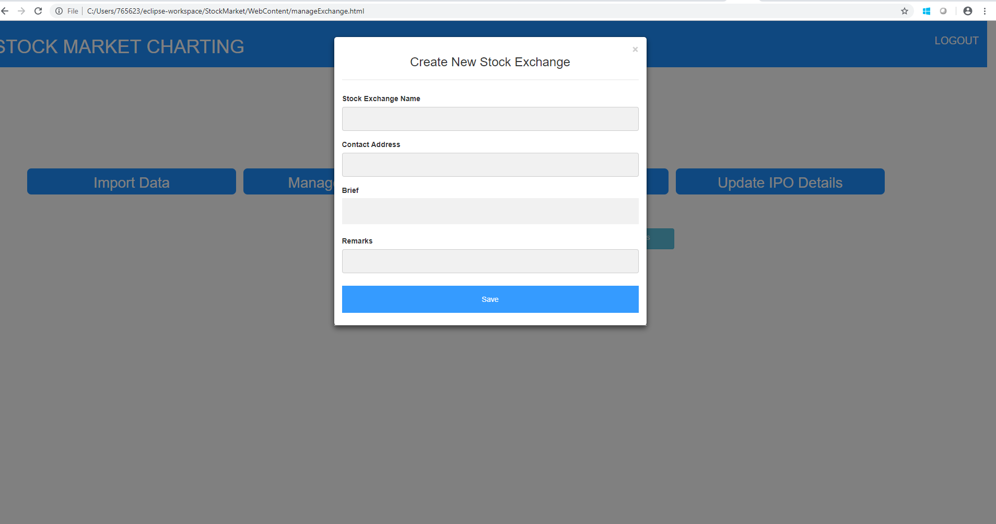

LIST STOCK DETAILS

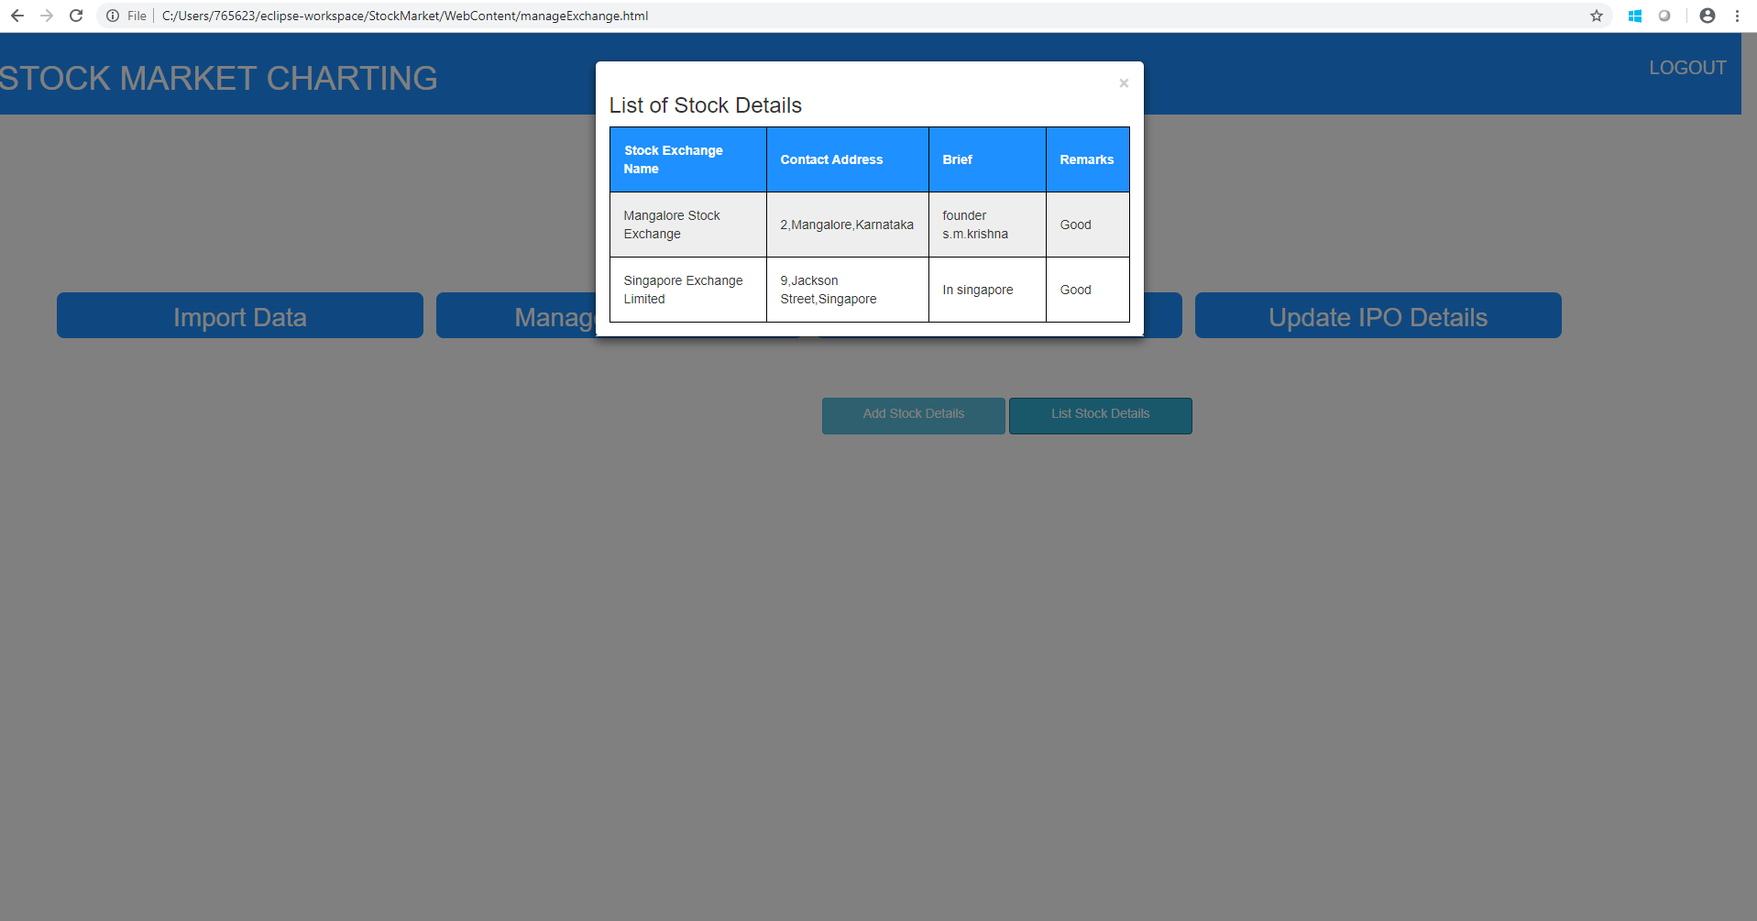

ADD IPO DETAILS

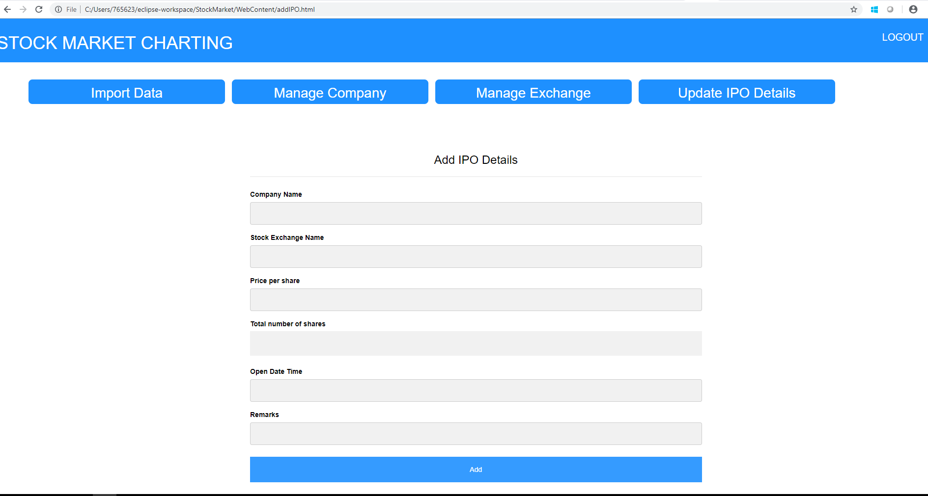

USER REGISTRATION FORM

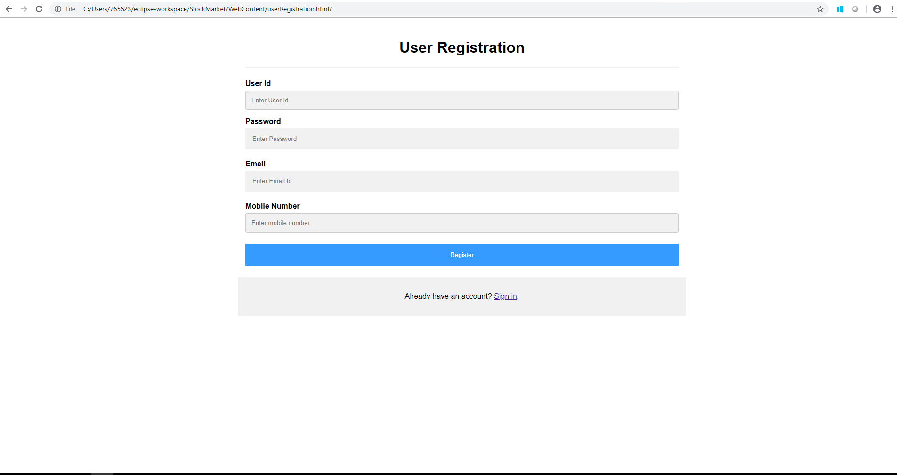

USER LOGIN

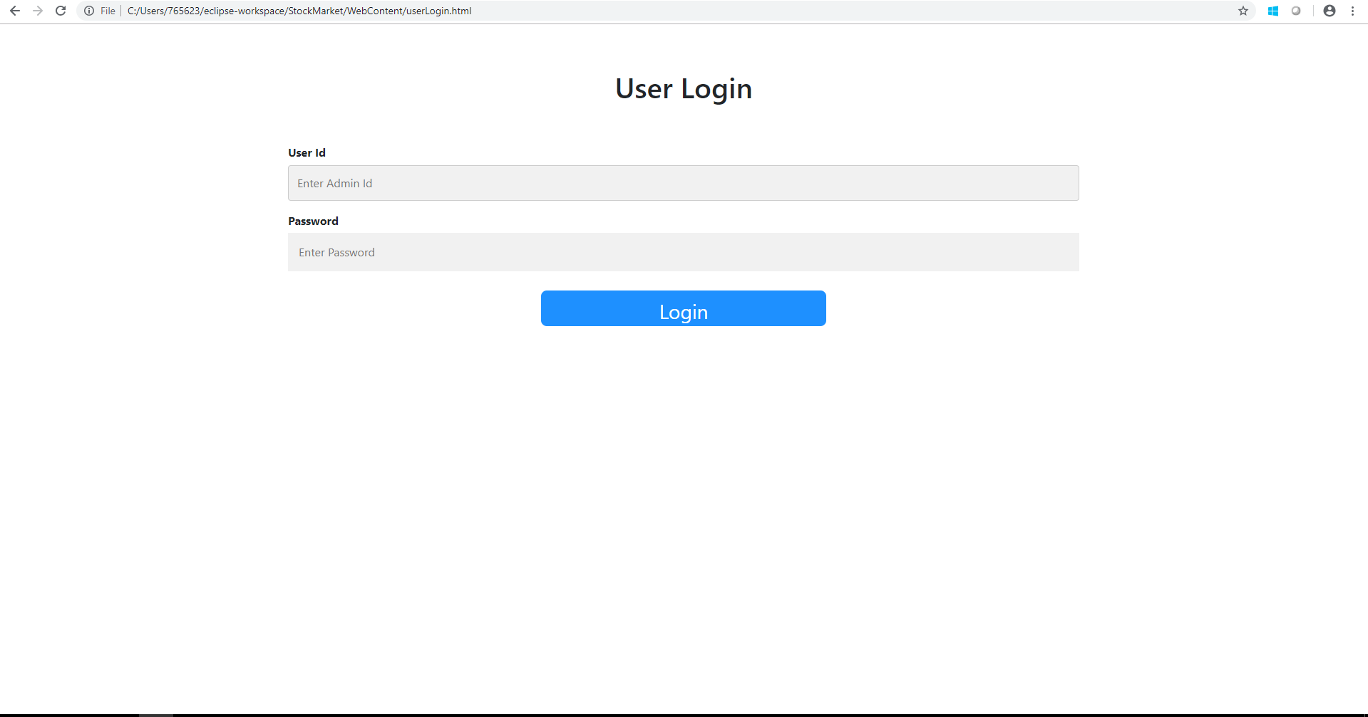

USER LANDING PAGE

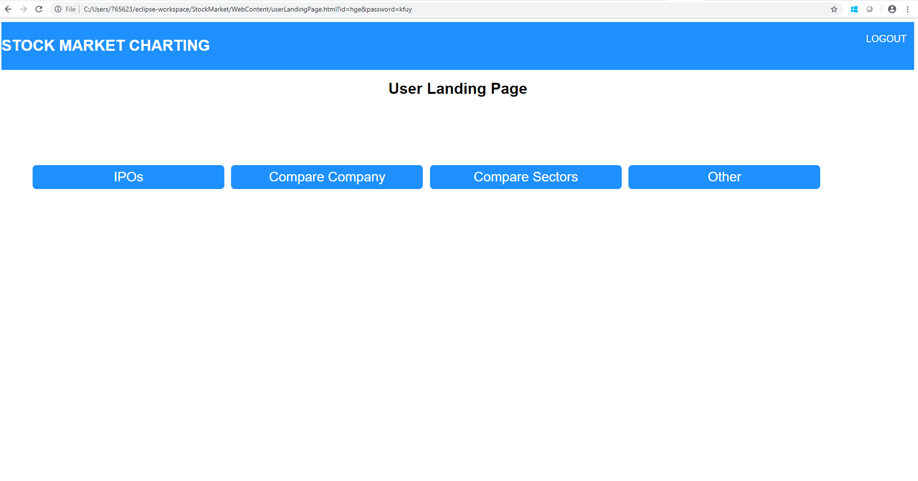

DISPLAY IPO DETAILS

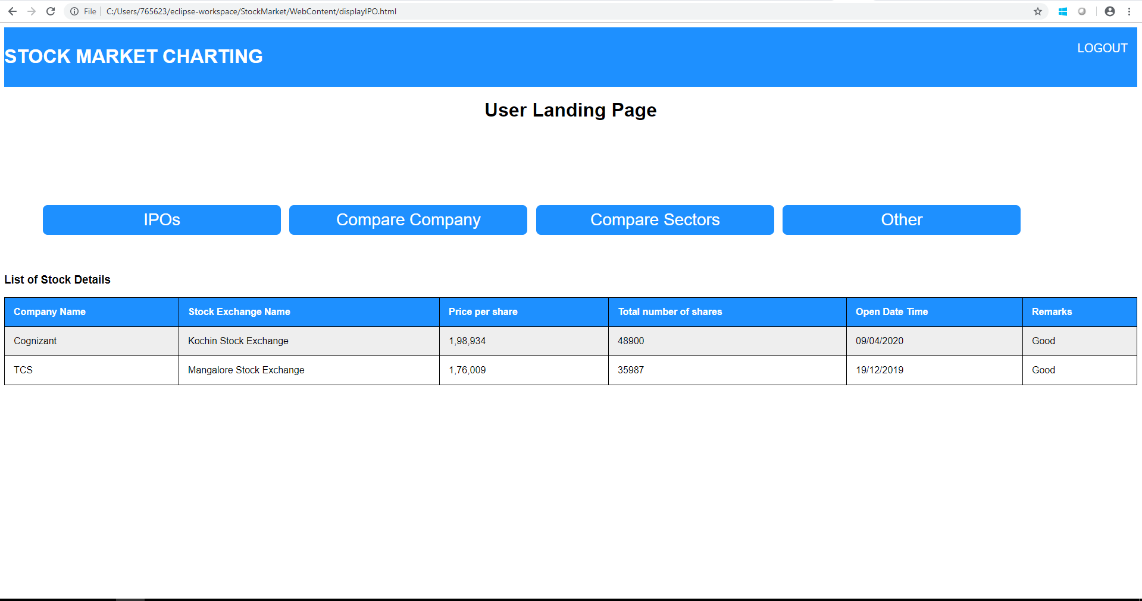

COMPARE COMPANY

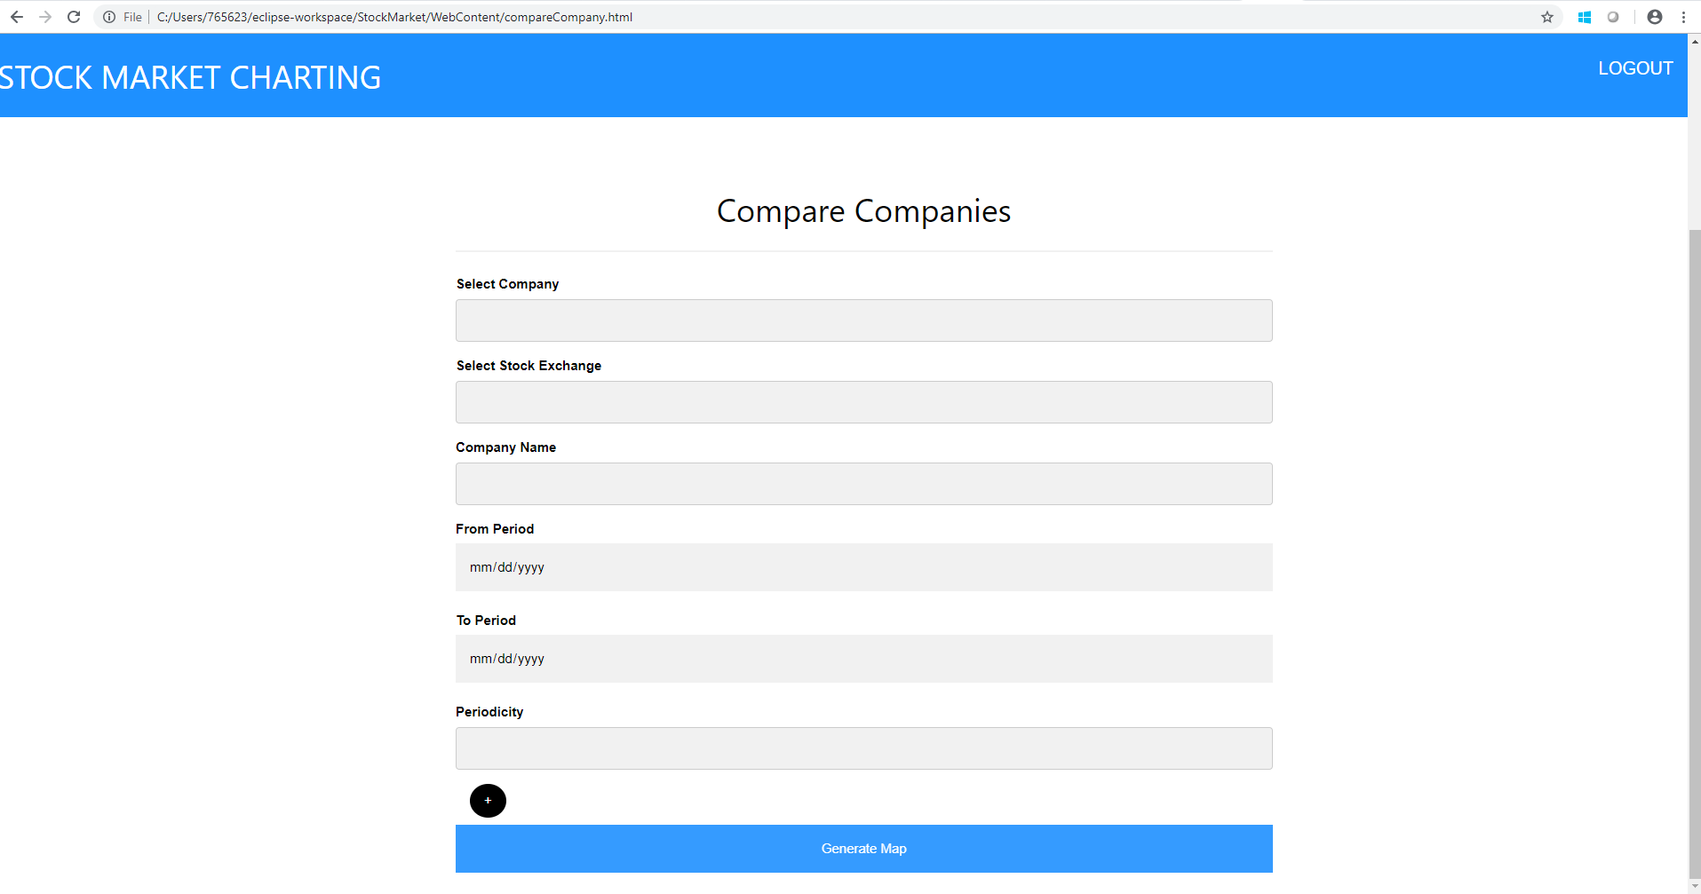

COMPARE SECTOR

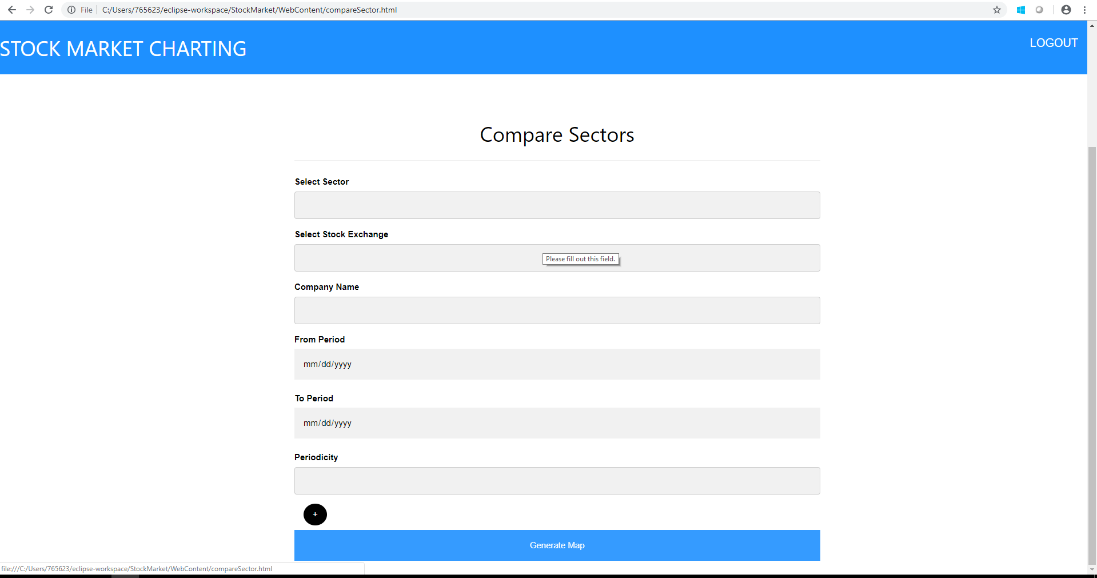

ER DIAGRAM

